3D Game Programming: Programming Assignment Three
YOU WILL RECEIVE ZERO POINTS IF YOU COPY and PASTE THE
MATERIALS OF OTHER! LATE SUBMISSION WILL BE DEDUCTED BY
30% a day.
In this assignment, you must implement the program individually. You should refer to the source code in the Template folder to do this assignment. You may refer to the demo and use the source code of the demo to do the assignment, too. You MUST implement something similar to the demo. If you don’t like the template, you can implement everything from scratch.

This is your first step to develop a flexible framework for a simple game. You will realize that it is important to design reusable classes and managers for maintaining different resources, e.g. weapons, monsters and particle systems. Please strengthen your C++ skill from now on. You will also learn how to manipulate vectors and the orientation of objects.

Deduction: File organization is wrong [-20%]; program crashes [-20%], No
student ID [-30%]. The program cannot be compiled on .NET2010 [-30%]. And something that is not similar to the demo.
There are THREE tasks. You must finish all of them.
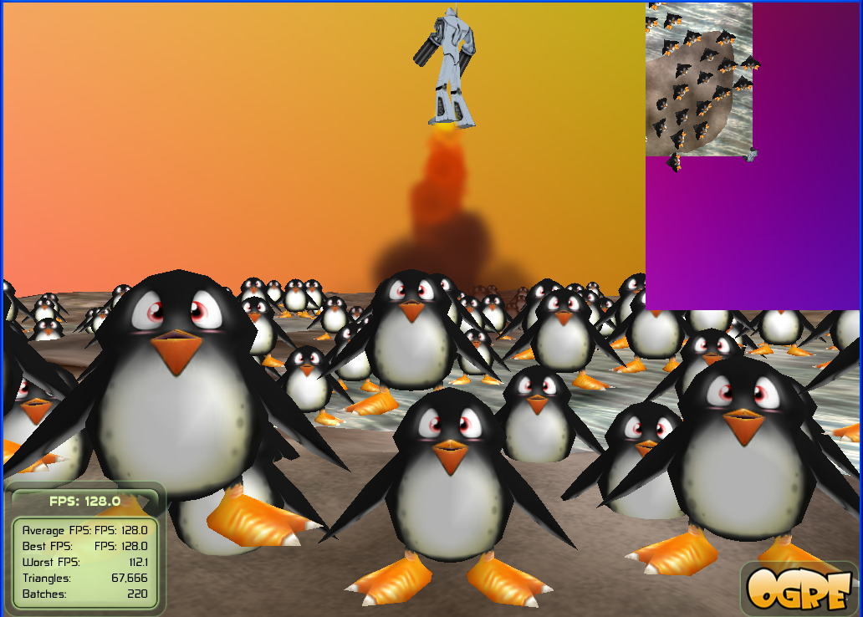
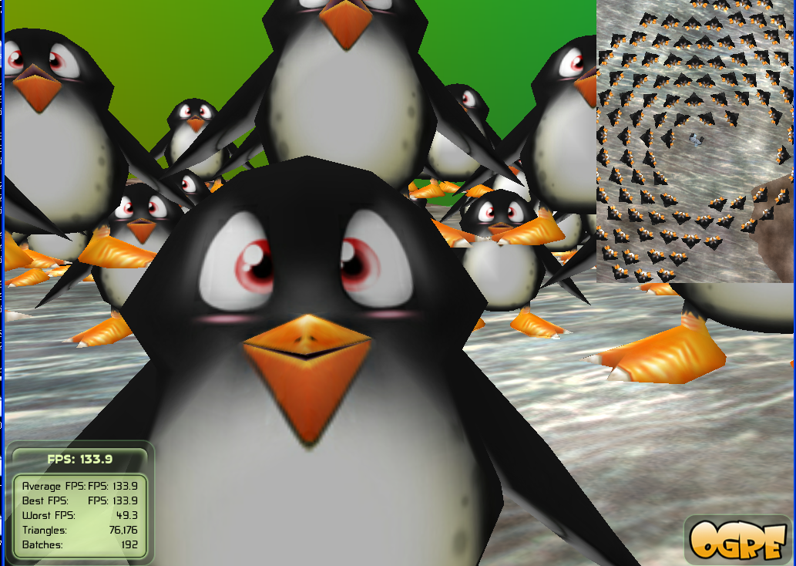
If the task is not described clearly to you, always refer to the demo.
Task One [75%]:
- [0%] Show your student name and ID as the title of the application window. MUST DO or receive zero point of score for this assignment.
In BaseApplicaiton::configure,
mRoot->initialize(true, “Name: X Y Z; ID: 0123456789”);
- [1%] Create a scene manager which can handle a terrain. Use it to create its own camera and viewport.
- [1%] The viewport occupies the entire screen space.
- [1%] Setup an ambient light and a spot light.
- [2+2%] Enable exponential fog and shadow. The fog density and the status of shadow are stored in a data file.
- [1%] Draw a height map and use it to create a terrain. Create a skybox.
- [2%] Create a plane and it is used for modeling the surface of water. It is assigned a water material. The material name is stored in a file. Create a big sphere and make it move up and down.
- [10%] Create a main character “robot” and control it to move around. The main character can be animated based on pre-defined animations. The key “T” is used for walking forward (AddTime(+)) and the key “G” for walking backward (AddTime(-)). If it is idle, its motion should be “Idle”.
- [3%] The camera should follow the main character.
- [2%] The main character should be invisible in this viewport.
- [5%] Create some monsters. The number of monsters is stored in a file. Assume the MAX number = 512.
- [5%] The monsters should be collision free. You can use spheres to bound the objects and use sphere-based method to detect collisions.
- [10%] The monsters chase the main character if they are too far from it.
- [10%] The monsters move away from the main character if they are too close to the main character.
- [5%] The monsters should look at the main character. But they can rotate about only the y-axis, i.e. yaw().
- [1%] The spot light should follow the main character. You can simply add an offset to the position of the main character for computing the light position.
- [3%] Use mouse move event for controlling the view direction of the main character.
- [1%] Emit a particle system which is attached to a movable object, such as the robot or the big sphere.
- [5%] Press the “SPACE_BAR” key to shoot balls. The trajectory of a ball is based on the projectile motion equation. The cool down time MUST be 0.1 second for shooting the next ball. The number of balls is less than or equal to a predefined number. The life time of a ball is 5 seconds. Use sphere.mesh for modeling balls (or bullets). Assume the MAX number = 128.
- [1%] If a ball hits the terrain, it should bounce off and its energy is reduced by a certain amount. If a ball hits the big target, i.e., the sphere, it should bounce off.
- [4%] If a ball hits the big sphere, play a sound.

Task Two [5%]:
- [1%] Create another camera and another viewport.
- [1%] The viewport occupies the upper right corner.
- [1%] The main character “robot” should be visible in this viewport.
- [1%] The camera is placed above the main character and it follows the main character so that a top down view is shown. Press “S” to zoom-in and press “D” to zoom-out.
- [1%] Disable overlays.
Task Three [20%]:
- Implement a data reader for the game to read the following items:
- Maximum number of monsters
- Maximum number of balls (bullets)
- The initial water level, i.e. y-coordinate of the plane. The plane is used for modeling the surface of water
- Material name for the plane
- Enable exponential fog or not, and the fog density.
- Enable shadow or not.
The file name should be in the form of STUDENT_ID_game_data.txt. For example, if your student ID is 123456789, then the file name MUST be 123456789_game_data.txt. If your student ID is wrong. Deduct all points.

File organization:
Make sure that your folder STUDENT_ID_NAME_03 must be organized as follows:
\lib : contains the precompiled libraries
\programs contains the assignment program
Inside \programs, it contains \assign_03.
Inside assign_03, we have the following items:
\bin : contains the executable, materials, dll, etc.
\media :contain media files
\docs : documentation, such as \html generated by doxygen
\source : contains all the .cpp and .h
\release
.sln : the project file for .NET2010
Submission:
1. Upload your source code to the E3 platform.
2. Submit a hardcopy report to describe the way how you finish the assignment.

File format example:
NUM_BULLETS 16
NUM_MONSTERS 256
MONSTER_SCALE 1.0
WATER_Y_COORD 30
WATER_MATERIAL Examples/WaterStream
EXP_FOG_ENABLED 1 0.0003
SHADOW_ENABLED 1
The keywords, such as MAX_BULLETS and MAX_MONSTERS and etc., must be the same.
You can assume that there is no syntax error.

Report format
Name: __________________________ Student ID: __________Assignment:_____
Email:___________________________

I CLAIM THAT THIS IS MY OWN WORK! YES PLEASE TICK YES.

[10%] Introduction [___________] // WORD COUNT. Must fill.
// At least 100 words.
// describe the purpose of this assignment
// describe the tasks that you have to finish

[20%] System Architecture [___________] // WORD COUNT. Must fill.
// [10%] At least 10 components
// [10%] Describe the system. At least 100 words.

[20%] Methods [___________] // WORD COUNT. Must fill.
//At least 200 words.
//Describe how you finish the tasks one by one.
//You must state clearly how to implement the program.

[40%] Discussion [___________] // WORD COUNT. Must fill.
//At least 400 words.
//You should discuss what you find the most interesting programming issues here.
//Also you may include some of the extra items that you implement
//Do you find any bugs in the demo program? Explain clearly.
//How to solve the bugs, etc…

[10%] Conclusion [___________] // WORD COUNT. Must fill.
//At least 100 words.
//What you have learnt, any problems, difficulties, the assignment tough or easy for
you? What do you suggest for the next assignment?

***BONUS: The best report(s) will be received at most 10% extra points.
Hints. You need not to follow the hint to implement the program. You can develop your approach on your own.
Task One
- [0%] Show your student name and ID as the title of the application window. MUST DO or receive zero point of score for this assignment.
In BaseApplicaiton::configure,
mRoot->initialize(true, “Name: X Y Z; ID: 0123456789”);
- [1%] Create a scene manager which can handle a terrain. Use it to create its own camera and viewport.
In chooseSceneManager( )
mRoot->createSceneManager(
ST_EXTERIOR_CLOSE, "primary");
Make sure that you store the returned pointer of the scene manager.

Create cameras: in createCamera( ). It’s better to create two functions createCamera_00( ) and createCamera_01( ) as there are two viewports.

After creating the camera, add a camera controller for the active camera. For example:
mCameraManArr[0] = new OgreBites::SdkCameraMan(mCamera);
There should be only one camera controller.

- [1%] The viewport occupies the entire screen space.

In createViewport( ), set the aspect ratio correctly. For example,
mCamera->setAspectRatio(
Ogre::Real(vp->getActualWidth()) / Ogre::Real(vp->getActualHeight()));

Set the visibility mask as : vp->setVisibilityMask(mask),
where vp is the viewport pointer and mask is the mask of the viewport. This mask is useful in filtering the objects that you don't want them to be rendered on this viewport.

- [1%] Setup an ambient light and a spot light.

- [2+2%] Enable exponential fog and shadow. The fog density and the status of shadow are stored in a data file.
/*
setFog should be put before SetWorldGeometry
*/
if (DATA_READER::isEnabledExpFog()) {
Real density = DATA_READER::getExpFogDensity();
mSceneMgr->setFog(FOG_EXP, fadeColour, density);
}

if (DATA_READER::isEnabledShadow()) {
mSceneMgr->setShadowTechnique(
SHADOWTYPE_TEXTURE_MODULATIVE);
//SHADOWTYPE_TEXTURE_ADDITIVE);
//SHADOWTYPE_STENCIL_MODULATIVE);
}

Make sure that the data reader is implemented correctly.

- [1%] Draw a height map and use it to create a terrain. Create a skybox.
mSceneMgr->setWorldGeometry("terrain.cfg");

mSceneMgr->setSkyBox( true, "Examples/TrippySkyBox");

- [2%] Create a plane and it is used for modeling the surface of water. It is assigned a water material. The material name is stored in a file. Create a big sphere and make it move up and down.

Use DATA_READER. Make sure that the functions are implemented correctly.

- [10%] Create a main character “robot” and control it to move around. The main character can be animated based on pre-defined animations. The key “T” is used for walking forward (AddTime(+)) and the key “G” for walking backward (AddTime(-)). If it is idle, its motion should be “Idle”.

Implement:
void MAIN_CHAR::update(const Ogre::FrameEvent& evt)

Implement:
bool BasicTutorial_00::keyPressed( const OIS::KeyEvent &arg )

bool BasicTutorial_00::keyReleased( const OIS::KeyEvent &arg )

- [3%] The camera should follow the main character.
Attach the camera to the main character. In the update function of the main character, set the position and direction of the camera properly.

- [2%] The main character should be invisible in this viewport.
So we need to set the visibility flag of the main character.

- [5%] Create some monsters. The number of monsters is stored in a file. Assume the MAX number = 512.

In createScene( ),
mMonsterMgr->setMaxMonstersNum(
DATA_READER::getMaxMonstersNum());

Set the target of the monsters as the main character.
mMonsterMgr->setTargetForMonsters(mMainChar);

The motion of the monster is defined in
void MONSTER::update(const Ogre::FrameEvent& evt)

- [5%] The monsters should be collision free. You can use spheres to bound the objects and use sphere-based method to detect collisions.

void MONSTER_MANAGER::update(const Ogre::FrameEvent& evt) updates the monsters and then hand collision.

In void MONSTER_MANAGER::update(const Ogre::FrameEvent& evt)

Implement and call
resolveMonsterTargetCollision() and
resolveMonsterCollision().

void MONSTER_MANAGER::resolveMonsterCollision()
resolves the collision problem between monsters.

- [10%] The monsters chase the main character if they are too far from it.

Implement void MONSTER::update(const Ogre::FrameEvent& evt)

- [10%] The monsters move away from the main character if they are too close to the main character.

Implement void MONSTER::update(const Ogre::FrameEvent& evt)

- [5%] The monsters should look at the main character. But they can rotate about only the y-axis, i.e. yaw().
In Monster::updateViewDirection()

if (mTarget == 0) return;
Vector3 pos = mTarget->getPosition();
Vector3 target_pos = mSceneNode->getPosition();
target_pos.x = pos.x;
target_pos.z = pos.z;

mSceneNode->lookAt(target_pos, Node::TS_WORLD);
mSceneNode->yaw(Radian(3.14159));

- [1%] The spot light should follow the main character. You can simply add an offset to the position of the main character for computing the light position.
- [3%] Use mouse move event for controlling the view direction of the main character.
Use void MAIN_CHAR::attachCamera(Camera *a_Camera) to attach the camera to the main character.

In MAIN_CHAR::updateViewDirection(), use mCamera->getRealDirection() to obtain the camera direction and then set the view direction of the main character.

- [1%] Emit a particle system which is attached to a movable object, such as the robot.
- [5%] Press the “SPACE_BAR” key to shoot balls. The trajectory of a ball is based on the projectile motion equation. The cool down time MUST be 0.1 second for shooting the next ball. The number of balls is less than or equal to a predefined number. The life time of a ball is 5 seconds. Use sphere.mesh for modeling balls (or bullets). Assume the MAX number = 128.

void MAIN_CHAR::fireWeapon() is defined for firing the weapon.

Vector3 pos;
Vector3 direction;
if (mFireActionMode&FIRE_ACTION_NORMAL)
{
pos = getWeaponPosition();
direction = mCamera->getRealDirection();
mWeaponMgr->fire_Normal(pos, direction);
mFireActionMode ^= FIRE_ACTION_NORMAL;
}

- [5%] If a ball hits the terrain, it should bounce off and its energy is reduced by a certain amount. If a ball hits the big target, i.e., the sphere, it should bounce off.

Implement: void WEAPON::update(const Ogre::FrameEvent& evt)

mLifeTime -= evt.timeSinceLastFrame;
if (mLifeTime < 0 ) {
mLifeTime = 0;
mSceneNode->setVisible(false);
mIsAlive = false;
return;
}
Real t = evt.timeSinceLastFrame;
Vector3 pos = mSceneNode->getPosition();
pos += mVelocity*t;

Vector3 grav(0,-29.8, 0);
mVelocity += grav*t;

Vector3 new_pos = pos;
Real r = 5;
new_pos -= Vector3(0, 1, 0)*r;
//Check collision and reduce its speed magnitude if it hits something. Finally, set the position.
……
mSceneNode->setPosition(pos);

Implement :
bool projectScenePointOntoTerrain_NegDirection(
Ogre::Vector3 &p)

Implement:
bool WEAPON::hitTarget_Sphere(const Vector3 &p, Real r )
For example:
Vector3 pos = mSceneNode->getPosition();
if ( r >= pos.distance( p ) ) {
Vector3 normal_dir = pos - p;
normal_dir.normalise( );
Vector3 new_pos = p + (r+0.5)*normal_dir;
mSceneNode->setPosition( new_pos );
Real d = mVelocity.dotProduct( normal_dir );
if ( 0.0 >= d ) {
mVelocity = mVelocity - d*normal_dir;
}
flg = true;

- [4%] If a ball hits the big sphere, play a sound.
Play a sound.
Note:
To update the main character, use void MAIN_CHAR::update(const Ogre::FrameEvent& evt)

if (mActionMode & ACTION_WALK_FORWARD) {
walkForward(evt);
}
if (mActionMode & ACTION_WALK_BACKWARD) {
walkBackward(evt);
}

fireWeapon();
updateWeapon(evt);
Real sf = 3.0;
if (
(mActionMode & ACTION_WALK_FORWARD)
||
(mActionMode & ACTION_WALK_BACKWARD)
) {
Update the animation state of the main character
}
else {
}
Task Two [5%]:
- [1%] Create another camera and another viewport.
Here, we use the same scene manager as in Task One.

- [1%] The viewport occupies the upper right corner.
Set the visibility mask: vp->setVisibilityMask( mask ), where vp is the viewport. For example, mask = 0x10.

Set the aspect ratio of the viewport properly.

- [1%] The main character “robot” should be visible in this viewport.
Use setVisibilityFlags to set the mask properly.

- [1%] The camera is placed above the main character and it follows the main character so that a top down view is shown. Press “S” to zoom-in and press “D” to zoom-out.
Use a variable to store the height of the camera from the ground. Use it to change the height (i.e., y-coordinate) of the camera.

- [1%] Disable overlays.

Use setOverlaysEnabled

